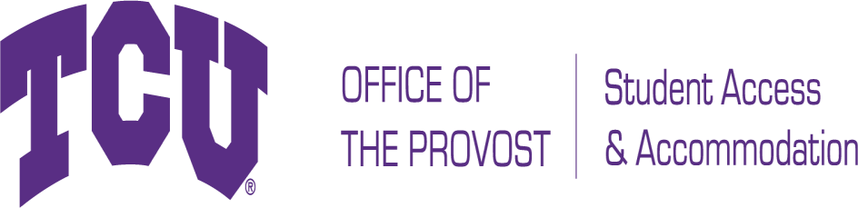

TCU Box 297008, Fort Worth, Texas 76129 studentaccommodation@tcu.edu
Phone: 817-257-6567 Fax: 817-257-5358 www.tcu.edu/access-accommodation

Documentation Guidelines for Specific Learning Disabilities
In order for Student Access and Accommodation (SAA) to evaluate requests for accommodations and/ or auxiliary aids and to determine eligibility for services, appropriate disability related documentation is needed. The documentation submitted should include an evaluation by an appropriately licensed professional and should demonstrate the current impact of the disability as it relates to the accommodations requested. The documentation should also include a description of any and all relevant functional limitations.

Specific Learning Disabilities are a group of disorders that may manifest as difficulty: (1) processing information by visual and auditory means, which may impact upon reading, spelling, writing, and understanding or using language, (2) prioritizing, organizing, doing mathematics, and following instructions, (3) storing or retrieving information from short- or long-term memory,
(4) using spoken language, and (5) difficulty with handwriting. An individual with a SLD will perform substantially and quantifiably below average in the affected academic skills area(s) for that individual’s age and can cause significant interference with academic performance as confirmed by individually administered standardized achievement measures and comprehensive clinical assessment. However, the underachievement cannot be attributable to an intellectual disability; economic/environmental disadvantage; chronic absenteeism; lack of education; lack of proficiency in the language of academic instruction; or neurological, motor, vision, or hearing disorders.

A Qualified Professional Must Conduct the Evaluation

Professionals conducting assessments must be qualified to do so. Comprehensive training in the differential diagnosis of Specific Learning Disabilities and direct experience in diagnosis and treatment of adolescents and adults with Specific Learning Disabilities is necessary. Professionals who are qualified to evaluate for a specific learning disability include neuropsychologists, clinical or educational psychologists, school psychologists, and certified educational diagnosticians with experience in the assessment of learning problems in adults. (Note: It is not appropriate for professionals to evaluate relatives or family members.)

Testing Must Be Current

Although a Specific Learning Disability is typically viewed as life-long, the severity and functional limitations may change over time. TCU assesses current impact on academic performance to determine the need for reasonable accommodations and services. Comprehensive testing is considered current up to three (3) years or with adult normed testing.

History of Accommodation

A high school plan such as an Individualized Education Program (IEP) or a 504 plan, or history of accommodations provided on the ACT or SAT is insufficient documentation in and of itself. However, in addition to current comprehensive documentation, it can be helpful in determining reasonable accommodations and services. SAA recommends providing this information when available. A prior history of accommodations without demonstration of a current need does not in itself the warrant the provision of like accommodations.

Significant Functional Limitations

- Based on the most current DSM criteria, the documentation must substantiate that the disability significantly limits
cognitive or academic functioning.
- Requested accommodations must be relevant to a University setting with supporting rationale.
- Assessment results/scores will be used to determine the presence of functional limitations.

Written Report

As explained below, the comprehensive report should include (A) the diagnostic interview, (B) assessment of aptitude/cognitive ability, (C) measurement of academic achievement, and (D) investigation of cognitive and information processing. The report should also include assessment of the major domains of cognitive and academic functioning, a list of tests administered including all standard scores, expert interpretation of the results, a clear diagnosis and statement of disability, discussion of the functional limitations and academic functioning levels. A complete and current Diagnostic and Statistical Manual of Mental Disorders (DSM) diagnosis must be provided with an accompanying description of the specific symptoms the student experiences. The diagnosis must be based on psycho-educational testing and a comprehensive clinical interview.

Diagnostic Interview- This should include (but is not limited to) relevant historical information regarding the student’s academic history and learning processes in elementary, secondary and postsecondary education. Also, the report should include a combination of observational data, gathered during the evaluation, and a summary of individual self-report, interviews with others, and previous testing completed by other clinicians. The report should also summarize any developmental history and current or relevant medical history. Also, the report must indicate the exclusion of the following as the primary disabling condition: intellectual developmental disability per DSM standards, blind or low vision disability, Deaf or hard of hearing, physical or systemic disability (that interferes with accurate test results), emotional disorder, poor educational background or lack of opportunity to learn, cultural differences or lack of experience with the English language.

Assessment of aptitude/cognitive ability: One comprehensive (full not brief) aptitude/IQ test with all subtests and standard scores provided. Examples include Weschler Adult Intelligence Scale (WAIS-IV) or Woodcock-Johnson IV Test of Cognitive Abilities.

Measurement of academic achievement: A standard score for the basic achievement areas of reading (word recognition, vocabulary, comprehension, fluency), math (calculation, problem- solving/reasoning, fluency), written language (mechanics, composition, fluency, spelling), and oral language (oral expression and listening comprehension) needs to be provided. Testing must include at least two achievement subtest scores in each specific area. Examples include Weschler Individual Achievement Test (WIAT-III) or Woodcock-Johnson IV Tests of Achievement. Please Note: The Wide Range Achievement Test-4 (WRAT-4) or the Nelson-Denny Reading Test are NOT a comprehensive measure of achievement and should not be used as the sole measure of achievement.

Areas of cognitive and information processing: Based upon the nature of the referral, the applicant's clinical presentation, and prior test results, evaluators should investigate realms of cognitive and information processing by conducting a minimum of two processing tests. These domains include, but are not limited to the following: memory, processing speed and cognitive fluency, attention, sensory-perceptual functioning, executive functioning, motor functioning, and visual acuity.

Student Access and Accommodation will make the final determination as to whether appropriate and reasonable accommodations are warranted and can be provided to the individual. All documentation submitted to SAA is considered to be confidential under FERPA guidelines and as outlined by University policy.

